Design Phase of the Joint Project around the Senegal Mauritanian Aquifer Basin led by the Regional Working Group

Deliverable number 7:

Review of transboundary cooperation models

DOCUMENT STATUS: APPROVED BY THE REGIONAL WORKING GROUP

|  |  |  |
| --- | --- | --- |
|  |  |  |
| With the financial support of |  |  |
|  |  |  |

Table of Contents

1 Introduction 3

2 Transboundary aquifer governance: Stock take 4

3 Analysis of shared aquifers' governance frameworks 5

Tab. 1. - The Genevese Aquifer 6

Tab. 2. - The Guaraní Aquifer System 8

Tab. 3. - The Iullemeden and Taoudeni/Tanezrouft Aquifer Systems (ITAS) 10

Tab. 4. - The Nubian Sandstone Aquifer System (NSAS) 12

Tab. 5. - The North-Western Sahara Aquifer System (NWSAS) 14

Tab. 6. - Al-Disi Aquifer 16

Tab. 7. - The Ocotepeque-Citalá Aquifer (Trifinio region) 17

Tab. 8. - The Stampriet Transboundary Aquifer System - STAS 19

Tab. 9. - The Limpopo Basin 21

Box 1. Presentation of the Southern African Development Community Groundwater Management Institute (SADC-GMI) 22

Tab. 10. - The Danube 23

4 Transversal analysis 24

5 Types of transboundary governance regimes - integrated, mono-functional and polycentric - a diversity of options. 25

5.1 The Integrated management regime 26

5.2 The Monofunctional Management Regime 27

5.3 The Polycentric Management Regime 28

5.4 Ideal-types of management regimes and multiple variations 29

Tab. 11. Examples of interpretation of integrated, mono-functional and polycentric regimes of the management of a share aquifer. 30

6 A re-read of transboundary aquifer governance models in the light of integrated, mono-functional and polycentric regimes. 30

Tab. 12. Classification of governance models per ideal-type 31

References: 35

## Introduction

Water management, whether applied to surface or underground resources, involves the management of flows that circulate independently of administrative and political boundaries. Such management implies a great level of complexity including, on the one hand, the alignment of different legal and governance frameworks intervening at different institutional levels and, on the other hand, the coordination between actors pursuing different and sometimes, divergent objectives.

This complexity becomes particularly acute in the management of transboundary aquifers. The sustainable management of this type of hydrological systems requires indeed, a good knowledge of the functioning of the aquifer systems, the quantities of available water, the conditions of withdrawal and renewal, co-existing uses and existing territoriality/scale issues. Groundwater management involves further and specific difficulties such as, the measurement of hydrological dynamics, the identification and determination of a functional perimeter that makes sense from environmental and institutional points of views.

Given such complexity, a multitude of options are available along with plethora of organizations and institutions in the name of transboundary management of the resource. These modes of organization result from negotiation and from power relations and they can be expressed in different forms and scales. They illustrate the diversity of views of the very nature of a river and they take practical form at different scales, sometimes sector-based, sometimes more broadly inclusive of use(r)s.

The objective of this deliverable is to reflect on the variety of organization modes applicable to the management of a transboundary aquifer. These thoughts should be key to, understand the specificities of the Senegalese-Mauritanian Aquifer Basin and, reflect upon an institutional architecture that would meet existing needs and potential developments.

In order to do so, the first part of the report presents (1) an inventory of existing governance systems applied to transboundary aquifers. The specificities of these systems as well as their implications on the identification of a given mode of organization, are discussed beforehand. The second part of the report (2), draws inspiration from a varied theoretical corpus. It presents generic governance regimes and allows for the discussion of different strategies for the definition of a transboundary aquifer management system. The word "regime" is used to show form of governance that has been stabilized through the introduction of a certain degree of coherence (Enjolras, 2008). A regime includes specific regulatory frameworks, objectives, instruments and actors. It can materialize through different territorial scales that does not necessarily correspond to political and administrative boundaries.

## Transboundary aquifer governance: Stock take

Although a significant amount of scholarly works have been devoted to the study of aquifers, much remains to be done in order to understand the functioning of its physical dynamics, as well as the monitoring, understanding and governance of its uses. At the transboundary level, access and use of an aquifer can generate tensions between States and the definition of a common governance framework is thus essential. While many mechanisms have been established for the management of surface water, they should be adapted to the specificities of aquifers’ functioning if they are to result in a model that matches empirical realities and the needs of involved actors:

* On the one hand, uncertainties or limited scientific knowledge around these resources (quantity and quality, interactions with surface water) can lead some actors (public authorities, managers, users, populations) to insufficiently recognise their transboundary nature. Carrying out scientific studies -necessary to remedy such lack of knowledge- requires relatively significant skills and resources.
* On the other hand, frequent shortcomings in terms of legal frameworks or national institutions devoted to groundwater policy, in many states, can prove the establishment of transboundary management mechanisms, difficult. In addition, the use of international law applicable to shared aquifers remains limited; and this factor discourages actors from engaging in the development of joint decision-making processes, which are relatively uncommon in the world until now.

Common management strategies and joint or coordinated actions, when they exist, are based on nimble mechanisms, which are more or less formal. They are also adapted to the functioning of a given aquifer system and its related local socio-economic and political contexts. In this sense, there is no single model that can be replicated. Depending on the degree of use and resulting impacts on various sides of the borders, different institutional structures and mechanisms will be necessary. Nevertheless, the most successful governance architectures have a number of common characteristics:

* Political will has been accompanied -to varying degrees- by the engagement of other stakeholders (such as the private sector, civil society, NGOs and international organizations). This phenomenon aimed at taking into account issues at stake local, national and international levels. Resource management is thus carried out through participation and consultation mechanisms.
* Roles and responsibilities of institutions in charge of actions’ implementation, have been clearly defined. These include purposefully created institutions, already existing transnational institutions or national public institutions (ministries, agencies, etc.).

## Analysis of shared aquifers' governance frameworks

Among the 592 existing transboundary aquifers[1] (IGRAC, 2015), a limited number of existing models for the governance of a transboundary aquifer was identified. The following section presents, first (1) these different models with regard to their legal framework, institutional mechanisms, dispute settlement mechanisms and the source of transboundary cooperation. It then presents (2) transversal analysis of these models in the light of exchanges carried out with practitioners involved in the conduct of a number of mechanisms.[2] The aquifers studied here are shown on the following map:

Fig 1. Existing governance models for transboundary aquifers

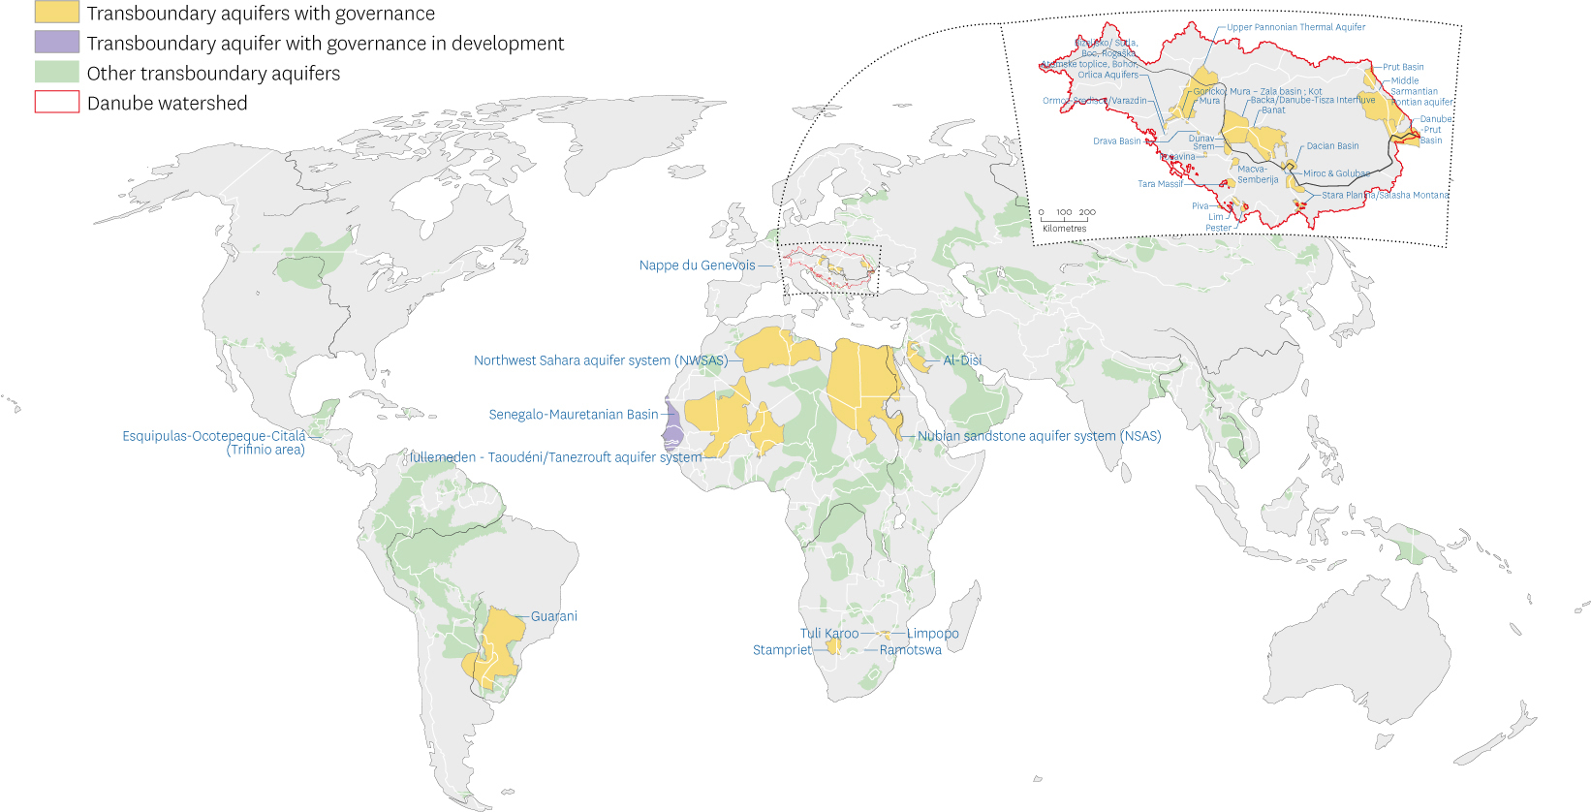

© Geneva Water Hub (2020)

Source: International Groundwater Resources Assessment Centre (IGRAC)

|  |  |  |
| --- | --- | --- |
| - The Genevese Aquifer | | |
| Geographical scope (countries) | | Switzerland, France |
| Climate (Köppen classification) | | Temperate oceanic climate (humid) |
|  |  |  |
| Legal framework | Arrangement, Agreement or other legal basis | Convention on the protection, utilisation, recharge and monitoring of Franco-Swiss Genevese aquifer  (in substitution of the "Arrangement on the Protection, Utilisation, and Recharge of the Franco-Swiss Genevese aquifer" - 1978) |
| Signature | 2007 |
| Implementation | 2008 |
| End | 2038 (possible extension until 2041) |
| Basic principles | Monitoring of the volume extracted by users  Monitoring duty of the water quality by the State of Geneva and French territorial authorities in order to prevent pollution  Duty to take appropriate protection measures in the event of a pollution  Resource sharing (dispensations to the limit can be accepted after consultations)  (The artificial recharging station belongs to the Genevese party only, France contributes financially according to a calculation method stated in the agreement.) |
|  |  |  |
| Institutional mechanism | Organisational structure of the institutional mechanism | The Genevese Aquifer Management Commission (“Commission”)  (the Community of the Annemassienne Region, the Community of the Genevois Rural Districts, and the Rural District of Viry, the Republic and Canton of Geneva)  Secretariat of the Commission: the aquifer office of the Geneva Canton and the Community of the Annemassienne Region |
| Function | **Propose** an annual utilization program according to the needs, measures to protect groundwater or to remedy causes of pollution  **Provide** technical opinion on the construction / modification of extraction works  **Audit** construction and operation costs for the purpose of cost sharing  **Oversee** the building of new equipments  **Control** the hydraulic infrastructures, volume of water extracted, the aquifer level, and the water quality |
| Dispute settlement mechanisms | | Franco-Genevese Regional Committee (conciliation)  Franco-Swiss Consultative Commission for Problems of Neighborliness between the canton of Geneva and the French departments of Ain and Haute-Savoie (settlement) |
|  | |  |
| Origin of the transboundary cooperation | | Fall in the groundwater table (years 1960-1970) due to overexploitation. The artificial recharge of the aquifer was less costly to implement than the construction of a treatment plant for the water of the lake. At the beginning, the cooperation was limited to quantitative objectives only and has then been extended to a qualitative management of the resource. |

|  |  |  |
| --- | --- | --- |
| - The Guaraní Aquifer System | | |
| Geographical scope (countries) | | Brazil, Argentina, Paraguay, Uruguay |
| Climate (Köppen classification) | | Tropical savanna climate – Dry winter (North)  Humid subtropical climate (South) |
|  |  |  |
| Legal framework | Arrangement, Agreement or other legal basis | Guaraní Aquifer Agreement ("Acuerdo sobre el Acuífero Guarani") |
| Signature | 2010 |
| Implementation | Pending receipt by Brazil, as the depositary, of the letter notifying the ratification by Paraguay |
| End | Unlimited duration |
| Basic principles | State sovereignty  Equitable and reasonable use of water resources  Obligation not to cause significant harm  Cooperation  Exchange of data and information  Prior notification of planned projects |
|  |  |  |
| Institutional mechanism | Organisational structure of the institutional mechanism | Commission of the Guaraní Aquifer, under the auspices of the La Plata Basin Treaty  (membership and functioning of the Commission are still to be defined and will be subject to a separate agreement) |
| Function | **Coordinate** the implementation of the agreement  **Promote** cooperation  **Advise** countries (provide recommendations for dispute settlement) |
| Dispute settlement mechanisms | | Direct negotiations of the countries, which are obligated to inform the Commission (conciliation)  Additional protocol for arbitration foreseen but yet to be defined |
|  | |  |
| Origin of the transboundary cooperation | | 2003-2009: GAS ("Guarani Aquifer System") project, implemented by the 4 countries sharing the resource, the Global Environmental Facility (GEF), the World Bank (WB) and the Organisation of American States (OAS)  2004 : Discussions within the framework of the MERCOSUR which led to a draft treaty in 2005 (never adopted due to disagreements on the dispute settlement mechanisms) |

|  |  |  |
| --- | --- | --- |
| - The Iullemeden and Taoudeni/Tanezrouft Aquifer Systems (ITAS) | | |
| Geographical scope (countries) | | Mali, Niger, Nigeria, Algeria, Benin, Burkina-Faso, Mauritania |
| Climate (Köppen classification) | | Warm desert climate (North)  Warm semi-arid climate – dry season the summer (South) |
|  | | |
| Legal framework | Arrangement, Agreement or other legal basis | **2009 -** Memorandum of Understanding (MoU) relating to the setting up of a Consultative Mechanism for the management of the Iullemeden Aquifer System between Mali, Niger and Nigeria  **2014 -** Memorandum of Understanding (MoU) for the establishment of a Consultative Mechanism for the ITAS between the 7 countries |
| Signature | 2014 (Principles of the agreement) |
| Implementation | Pending (awaiting the endorsement of Algeria, Burkina Faso and Mauritania) |
| End | Unspecified |
| Basic principles | Integrated and sustainable management of groundwater resources  Cooperative management of risks  Equitable and reasonable use of the water resources  Duty not to cause significant cross-border damage  Precaution principle  Polluter-pays principle  Principle of protection and conservation of ecosystems  Data and information sharing  Prior notification of planned projects  Prior notification of planned measures |
|  |  |  |
| Institutional mechanism | Organisational structure of the institutional mechanism | The Consultative Mechanism includes:  Council of Ministers  Executive secretariat  Permanent scientific and technical committee  National technical and scientific committees  Coordination unit |
| Function | **Identify** the risks to which the aquifer is exposed  **Gather** technical information on the aquifer and possibly information regarding its use  **Organise** data sharing on technical and scientific aspects  **Undertake** joint studies  **Develop** a joint monitoring network  **Support the negotiation** of financing and loans  **Implement** the roadmap of the Memorandum |
| Dispute settlement mechanisms | | Good offices of the Mechanism (mediation of consultation)  Decision of the Council of Ministers based on the scientific and technical committee (settlement in the absence of conciliation by the good offices)   Conciliation commission of the African Union (referral by the parties in the absence of satisfactory solution)  International Court of Justice (arbitration in the event of a failure to achieve a conciliation) |
|  | |  |
| Origin of the transboundary cooperation | | "Management of hydrogeological risks in the Iullemeden aquifer system" project (2007-2010) funded by the United Nations Environment Programme (UNEP) / Global Environmental Facility (GEF) and implemented by the Sahara and Sahel Observatory (OSS). |

|  |  |  |
| --- | --- | --- |
| - The Nubian Sandstone Aquifer System (NSAS) | | |
| Geographical scope (countries) | | Libya, Egypt, Chad, Sudan |
| Climate (Köppen classification) | | Warm desert climate |
|  |  |  |
| Legal framework | Arrangement, Agreement or other legal basis | Constitution of the Joint Authority for the study and development of the Nubian Sandstone Aquifer (“Joint Authority Agreement”)  ToR for the monitoring and exchange of groundwater information of the Nubian Sandstone Aquifer System  ToR for monitoring and data sharing |
| Signature | 1992 (Constitution of the Joint Authority) 2000 (ToR for the monitoring and exchange of information) 2000 (ToR for monitoring and data sharing) |
| Implementation | 1992 (Constitution of the Joint Authority) 2000 (ToR for the monitoring and exchange of information) 2000 (ToR for monitoring and data sharing) |
| End | Unspecified |
| Basic principles | Sustainable and mutually beneficial development of the aquifer  Need for an assessment of aquifer resources  Data exchange and information sharing  (According to the 2 ToRs of 2000) |
|  |  |  |
| Institutional mechanism | Organisational structure of the institutional mechanism | "Joint Authority" for the study and development of the Nubian Sandstone Aquifer waters, including:  - A Board of Directors which consists of three directors from each Member State - An Executive Director |
| Function | **Collect and analyze** information gathered by the Member States  **Disseminate** information  **Execute** studies (water quantity and quality, environmental aspects of developing the aquifer)  **Design** common policies for groundwater management (development and utilization of the water resource, decrease in consumption)  **Promote** cooperation  **Foster** relationships with international organizations |
| Dispute settlement mechanisms | | None |
|  | |  |
| Origin of the transboundary cooperation | | 1972-1974: Regional project for the assessment of groundwater resources of the NSAS (Libya, Egypt, Sudan) funded by the United Nations Educational, Scientific and Cultural Organization (UNESCO) and the United Nations Development Programme (UNDP)  1978-1988: Transboundary project on the main regional aquifer of North-East Africa (Libya, Egypt, Sudan) funded by the United Nations Department for Technical Cooperation and Development (UNDTCD), the United Nations Environment Programme (UNEP) and the United Nations Development Programme (UNDP)  1998-2002: Regional strategy for the use of the Nubian Sandstone Aquifer System, project implemented by the Centre for Environment and Development for the Arab Region and Europe (CEDARE)  2005-2007: Nubian project ("Formulation of an action programme for the integrated management of the shared nubian sandstone aquifer") implemented 4 countries sharing the resource and the Global Environmental Facility (GEF) / United Nations Development Programme (UNDP) / International Atomic Energy Agency (IAEA) |

|  |  |  |
| --- | --- | --- |
| - The North-Western Sahara Aquifer System (NWSAS) | | |
| Geographical scope (countries) | | Algeria, Tunisia, Libya |
| Climate (Köppen classification) | | Warm desert climate |
|  |  |  |
| Legal framework | Arrangement, Agreement or other legal basis | **2002 -** Minutes of a meeting at the FAO between the 3 countries setting up a "Consultative Mechanism"  **2006 -** Joint Ministerial Statement by the 3 Ministers of water  **2015 -** Draft of the protocol |
| Signature | 2002 |
| Implementation | 2007 |
| End | unspecified |
| Basic principles | Coordinate, promote and facilitate the rational management of the NWSAS water resources |
|  |  |  |
| Institutional mechanism | Organisational structure of the institutional mechanism | The Coordination Mechanism includes: - Council of Ministers in charge of water resources - Permanent technical committee - Coordination unit with a coordinator (rotating biannual unit, based at the Observatory of the Sahara and the Sahel - OSS) |
| Function | **Conduct** joint scientific studies  **Update** data / information bases  **Disseminate** information  **Monitor** indicators of management of the shared resource  **Promote** participation in resource management |
| Dispute settlement mechanisms | | None |
|  | |  |
| Origin of the transboundary cooperation | | 1969-1972: ERESS project (study of the water resources in the North-Western Sahara region), funded by the United Nations Educational, Scientific and Cultural Organization (UNESCO)  1980-1983: Project RAB/80/011 (update of the study of the water resources in the North-Western Sahara region), funded by the United Nations Development Programme (UNDP)  1999-2002: SASS I (first phase of the SASS project, SASS being the French acronym for NWSAS), funded by the Swiss department for Development and Cooperation (SDC), the International Fund for Agricultural Development (IFAD), the Food and Agriculture Organization (FAO), the United Nations Educational, Scientific and Cultural Organization (UNESCO) and the German Corporation for International Cooperation (GIZ).  2003-2006: SASS II (second phase of the SASS project or North-Western Sahara Aquifer System - “NWSAS” project), funded by the Global Environmental Facility (GEF) / the United Nations Environment Programme (UNEP), the French Facility for Global Environment (FFEM), SDC, UNESCO and GIZ.   2007-2013: SASS III (third phase of the SASS project or operational recommendations for a sustainable management of the water resources of the NWSAS), funded by FFEM |

|  |  |  |
| --- | --- | --- |
| - Al-Disi Aquifer | | |
| Geographical scope (countries) | | Jordan, Saudi Arabia |
| Climate (Köppen classification) | | Warm desert climate |
|  | |  |
| Legal framework | Arrangement, Agreement or other legal basis | Agreement for the management and utilization of the groundwater in the Disi - Saq Aquifer |
| Signature | 2015 |
| Implementation | 2015 |
| End | Revised every 25 years |
| Basic principles | Moratorium on water abstraction in a protected area (or "prohibited area") within a period of five years  Limitation of the water extracted from a protected area ("management area") to municipal purposes only  Pollution contingency plan (prohibition of certain types of wells, pollutant discharge prohibition) |
|  |  |  |
| Institutional mechanism | Organisational structure of the institutional mechanism | Technical Joint Committee  (normally composed of five members from each Party to the Agreement, and co-headed by representatives from both side - yet, the committee never met) |
| Function | **Oversee** the implementation of the agreement  **Monitor** groundwaters (amount extracted, quality, level)  **Collect and share** information |
| Dispute settlement mechanisms | | None |
|  | |  |
| Origin of the transboundary cooperation | | Overexploitation by Saudi Arabia for irrigated agriculture and "race" for extraction by Jordan to secure water rights. Necessity for the government of Saudi Arabia to maintain political stability in Jordan, including by strengthening water cooperation. |

|  |  |  |
| --- | --- | --- |
| - The Ocotepeque-Citalá Aquifer (Trifinio region) | | |
| Geographic scope (country) | | Salvador, Honduras |
| Climate (Köppen Classification) | | Tropical Savanah climate with dry winter characteristics |
|  | |  |
| Legal framework | Arrangement, Agreement or other legal basis | “Letter of intent for the creation of a future binational cooperation mechanism for sustainable management", among :  municipalities, water treatment and distribution authorities, association of Trifinion municipalities, Secretariat of the Trifinio Plan, Ministries of water resources of both countries. |
| Signature | 2019 |
| Entry into force | Formalisation of the mechanism planned for December 2021 |
| End | Not specified |
| Basic Principles | State sovereignty  Principle of human right to water  Importance given to indigenous people  Necessity of reliable data for cooperation  Integration of SGD and climate change. |
|  |  |  |
| Institutional mechanisms | Organisation of institutional mechanism | Intention to establish in the future a “Committee for binational management” incorporated within the trinational institutional frame for the implementation of the Trifinio Plan. It would bring together member from: municipalities, distribution and treatment authorities, Secretariat of the Trifinio Plan (including Guatemala), Ministries of water resources of both countries. |
| Function | Function in the future:  **Collect** necessary data for the management of the aquifer.  **Exchange** information among stakeholders.  **Identify** financial sources for activities.  Conceive a binational strategy for the conservation, protection and sustainable use of the aquifer. |
| Dispute settlement mechanisms | | None (the letter of intent is not legally binding) |
|  | |  |
| Origin of the transboundary cooperation | | GGRETA project (governance of transboundary aquifer resources management) financed by the Swiss Development Cooperation (SCD) and implemented by the International hydrological programme of UNESCO in collaboration with IUCN and IGRAC. |

|  |  |  |
| --- | --- | --- |
| - The Stampriet Transboundary Aquifer System - STAS | | |
| Geographic scope (country) | | Afrique du Sud, Namibie, Botswana |
| Climate (Köppen Classification) | | Hot Desert Climate |
|  |  |  |
| Legal framework | Arrangement, Agreement or other legal basis | Agreement on the creation of the Orange-Senqu Commission “ORASECOM” (also signed by Lesotho) |
| Signature | 2000 |
| Entry into force | 2003 (entry into force of the revised SADC protocol) |
| End | Possibility to withdraw from the agreement whiten 12 months minimum following a written notification. |
| Basic Principles | The agreement subscribe to the principle of the Helsinki rules, the UN Water Convention and the (revised) Protocol on Shared Watercourses of the Southern African Development Community (SADC):   Reasonable and ecological use of the resource  Integrated management of water resources  Obligation not to cause significant harm  Universal participation and cooperative governance  Equitable utilisation  Peaceful conflict resolution |
|  |  |  |
| Institutional mechanisms | Organisation of institutional mechanism | Groundwater hydrology committee of the ORASECOM technical working group. |
| Function | **Implement** tasks delegated by the Commission des tâches déléguées par la Commission **Report** to the technical working group (and not the ORASECOM Council) |
| Dispute settlement mechanisms | | Amicable resolution of conflicts through consultation and negotiation among parties. Tribunal established by article 16 of the SADC Treaty of 1992. |
|  | |  |
| Origin of the transboundary cooperation | | 2000: Agreement establishing the Commission of the Orange-Senqu river among the governments of Botswana, Lesotho, Namibia and South Africa.  2013-2015: Phase 1 of the GGRETA project (governance of transboundary aquifer resources), that allowed for the establishment of scientific knowledge of the shared aquifer.   2016-2018: Phase 2 the GGRETA project, that allowed for the reinforcement of academic and institutional capacities in relation to groundwater governance at national and transboundary levels to support the implantation of the Multi Country Cooperation Mechanism (MCCM).  (The GGRETA project was financed by the Swiss Development Cooperation and implemented by the International Hydrological Programme of UNESCO in cooperation with IUCN and IGRAC. |

|  |  |  |  |  |
| --- | --- | --- | --- | --- |
| - The Limpopo Basin | | | | |
|  | | **Ramotswa Aquifer** | **Tuli Karoo Aquifer** | **Limpopo Aquifer** |
| Geographic scope (country) | | South Africa, Botswana | South Africa Botswana, Zimbabwe | Mozambique, South Africa, Zimbabwe, Bostwana |
| Climate (Köppen Classification) | | Hot semi-arid climate - steppe (north)  Subtropical humid climate - dry season in winter (south) | | |
|  |  |  |  |  |
| Legal framework | Arrangement, Agreement or other legal basis | Creation of a groundwater committee within the Limpopo Commission (LIMCOM, agreement signed in 2003) for the assessment and management of all 3 aquifers.  Memorandum of Understanding between the Secretariat of the LIMCOM and the Groundwater Management Institute (SADC-GMI) of the SADC to provide technical support to the SADC-GMI. | | |
| Signature | 2018 (creation of the LIMCOM) 2019 (MoU) | | |
| Entry into force | 2018 (creation of the LIMCOM) 2019 (MoU) | | |
| End | Possibility to withdraw from the LIMCOM with written notification. | | |
| Basic principles | The agreement creating the LIMCOM subscribe to the principle of: the United Nations’ Water Convention, Chp.18 of Agenda 21 as well as to “the spirit, values and objectives” of the (revised) Protocol on shared waters of the SADC:  Reasonable and ecological use of the resource  Integrated management of water resources  Obligation not to cause significant harm  Equitable utilisation | | |
|  |  |  |  |  |
| Institutional Mechanism | Organisation of institutional mechanism | Groundwater Committee of the Limpopo Commission “LIMCOM”:  - Representation of each State by 3 persons.  - Chairmanship on a rotational basis. | | |
| Function | The cooperation framework of the MoU aims to:  **Facilitate** the integration and harmonisation of provisions relative to groundwater at States and basin levels.  **Assist** in the up-date of protocols/agreements and providing options for groundwater (such as data sharing).  **Suggest** solutions through the Transboundary Diagnostic Analysis and Strategic Action Plan.  **Implement** studies and trainings **Collaborate** towards the establishment and the implementation of institutional arrangements for the management of transboundary aquifers.  **Organize** the set-up of a platform for the exchange of information as well as the set-up of an integrated system of data management. | | |
| Dispute settlement mechanisms | | Conflict resolution mechanisms provided for in the agreement setting-up the LIMCOM are as follows:  - Amicable resolution through negotiation among parties.  - If the négociation does not allow to reach an agreement within 6 months, possibility to bring the case to a tribunal established by article 16 of the SADC Treaty of 1992. | | |
|  | |  | | |
| Origin of the transboundary corporation | | RESILIM Programme (Resilience in the Limpopo basin 2015-2019) financed by USAID | | |

##### Box 1. Presentation of the Southern African Development Community Groundwater Management Institute (SADC-GMI)

SADC-GMI is a regional centre of excellence for groundwater management working under the strategic guidance of the Water Division of the SADC Secretariat. It provides support to the 16 SADC Member States that have established a legal framework for water cooperation through the Revised Protocol on Shared Watercourses in the Southern African Development Community (2000), which addresses surface water and groundwater connected systems. The Protocol potentially excludes solitary, non-recharging and fossil transboundary aquifers, since only aquifers connected to a transboundary river courses are considered (SADC-GMI, 2019).

SADC-GMI’s core mandate is to promote sustainable groundwater management and providing solutions to groundwater challenges in the SADC region through creating an enabling policy, legal and regulatory environment, capacity building, advancing research, supporting infrastructure development, and enabling dialogue and accessibility of groundwater information. It collaborates with academic and research institutions, civil society, the private sector and project implementing agents. The current key strategic objectives are to strengthen the SADC-GMI, improve knowledge management, build national and regional institutional capacity and lead national and regional coordination.

SADC-GMI is typically a tailor-made organisation that contributes to bridge the different frameworks at the transboundary level and mutualise some key activities such as capacity building. Such organization represents one possible way to frame coordination between existing normative frameworks for the management of groundwater. Taking into account that institutional arrangements develop iteratively over time (Blomquist & al. 2005), SADC Protocol provides strategic guidance as to how transboundary aquifers should be managed and developed (SADC-GMI, 2019).

|  |  |  |  |  |  |
| --- | --- | --- | --- | --- | --- |
| - The Danube | | | | | |
| Geographic scope (country) | | Dacie Basin (Romania, Serbia), Danube-Prut Basin (Romania, Moldavia, Ukraine), Drava (Basin Croatia, Hungary), Goricko, Mura – Zala, Kot Basin (Austira, Croatia, Hungary, Slovenia), Lim (Montenegro, Serbia), Macva-Semberija (Bosnia-Herzegovina, Serbia), Sarmantien Pontien mid aquifer (Roumana, Moldavia, Ukraine), Miroc & Golubac (Roumania, Serbia), Mura (Croatia, Hungary), Banat (Hungary, Romania, Serbia), Interfluve Backa/Danube-Tisza (Croatia, Hungary, Roumania, Serbia), Ormoz-Sredisce/Varazdin (Croatia, Slovania), Pester (Montenegro, Serbia), Piva (Montenegro, Bosnia-Herzegovina), Posavina (Bosnia-Herzegovina, Croatia), Prut Basin (Roumania, Moldavia), Dunav (Croatia, Serbia), Srem (Croatia, Serbia), Stara Planina/Salasha Montana (Bulgaria, Serbia), Tara Massif (Bosnia-Herzegovina, Serbia), Higher Pannonie Plain Basin (Slovakia, Austria, Hungary, Slovenia) | | | |
| Climate (Köppen Classification) | | Continental humide climate | | | |
|  | |  | | | |
| Legal framework | Arrangement, Agreement or other legal basis | Convention on cooperation for the protection and sustainable development of the Danube (also called “Convention for the protection of the Danube”). | | | |
| Signature | 1994 | | | |
| Entry into force | 1998 | | | |
| End | Possibility to withdraw from the agreement; withdrawal takes effect one year after the date of the receipt of the notification by the depositary. | | | |
| Basic principles | Sustainable and equitable management  Reasonable use of the resources  Preservation or improvement of the quality and ecological status Polluter pays principle  Precaution principle  Obligation not to cause significant harm | | | |
|  |  |  |  |  |  |
| Institutional Mechanism | Organisation of institutional mechanism | Working group on groundwater linked to the Monitoring and Assessment Experts Group of the ICPDR (International Commission for the Protection of the Danube River). | | | |
| Function | **Mapping** of groundwater to be protected as well as areas to be preserved for the supply (present or future) of drinking water  **Control** the pollution of groundwater resources, in particular by nitrates, pesticides and dangerous substances.  **Implementation** of the transboundary aspects of the European Water Framework Directive | | | |
| Dispute settlement mechanisms | | Amicable resolution of conflict through negotiation among parties, and if necessary with the help of the Commission.    If the negotiation does not reach an agreement within 12 months, the conflict can be brought in front of the International Court of Justice or an arbitration tribunal (defined in Annex V of the Convention) if either party chooses so. | | | |
|  | |  | | | |
| Origin of the transboundary cooperation | | The degradation of water quality in the Danube led 8 States to cooperate on “issues related to the management of the Danube’s waters” in 1985. | | | |

## Transversal analysis

These experiences show that, on the one hand, existing legal frameworks and institutional mechanisms are very diverse and, on the other hand, most of these frameworks adhere to the principles of international law on shared aquifers, such as the equitable distribution of resources, the obligation not to cause significant harm, the duty to share information and the duty to notify in advance of any measure that may have an impact beyond national borders.

It is also observed that interstate commitment to the governance of groundwater is sometimes grafted onto other commitments dealing with surface water. For example, the Danube Convention provides for the protection of aquifers in the basin; the management principles of the Stampriet system are contained in the Agreement establishing the Orange-Senqu Transboundary River Commission (ORASECOM); similarly, the cooperation mechanism for the aquifers of the Limpopo basin (Ramotswa, Tuli Karoo, Limpopo) is based on a Groundwater Committee attached to the River Commission; finally, the plan to create a "Binational Management Committee" for the Ocotepeque-Citalá aquifer is part of arrangements already in place for the Lampa River (tri-national association).

When agreements establish new institutions (e.g.: a Commission), inherent responsibilities are broadened. Thus, such institutions are generally empowered to propose and implement water use and planning programs. These new institutions undoubtedly constitute a solid basis for transboundary cooperation. On the other hand, agreements established by them must generally be supplemented by other legal conditions allowing their operation. The Guarani agreement is a good example: while it provides for the constitution of the Commission, within the framework of the La Plata river Commission, its composition and functioning are not defined and will therefore have to be the subject of a separate agreement. Other agreements may also be needed to define integrated water policies. In addition, when it comes to sharing information and monitoring, the state of the resource (quantity or quality), agreements commit parties to data exchange and joint monitoring but do not systematically specify the type of data to be exchanged or the framework of such monitoring mechanisms (location and depth of the wells, criteria for assessing the quality). These shortcomings therefore presuppose that clarifications will be done in a second step and require additional negotiations.

If these institutional architectures have the merit of founding the principles of shared governance, they remain incomplete to support concrete actions of cooperation. Some objectives require the adoption of policies at regional levels as well as, the adoption of additional documents. Discussions with consulted experts show that it may be preferable not to create new governance structures when already existing regional or supranational organizations bring together skills adapted to groundwater. Such a logic indeed allows for the allocation of more time and energy to awareness-raising efforts towards effective management of an invisible resource. Watershed management organizations, for example, can extend their expertise and scope to groundwater. The combined management of surface water and groundwater is then facilitated, and it reduces the difficulties in building a consolidated vision by avoiding organizations that work in silos. When a transboundary aquifer system is geographically located in a territory under the jurisdiction of two or more basin organizations, these bodies can develop a coordination mechanism for the governance of the entire system. For example, the International Commission for the Protection of the Danube River (ICPDR) coordinates with the Danube commission on navigation (Danube Commission) and with the International Sava River Basin Commission (ISRBC) on the Sava tributary.

In addition to this inventory and transversal analysis, the objective of this document is to provide additional reading keys to help define tailor-made institutional mechanisms which are in turn enabled to respond to both regional and specific issues. In this perspective, the following section aims at presenting generic models of governance inspired by scientific literature and empirical reality. Three main ideal-typical governance regimes are identified to provide clear options and different (and complementary) perspectives for the governance of a transboundary aquifer. Inspired by existing mechanisms for surface water management, these regimes can be reinterpreted to define tailor-made solutions.

## Types of transboundary governance regimes - integrated, mono-functional and polycentric - a diversity of options.

This section aims to present three main types of transboundary water governance regimes (Bréthaut & Pflieger, 2020). These regimes, conceptualized for the governance of surface water, can also be considered for groundwater resources. Based on different theoretical frameworks, three types of regimes are discussed: integrated regime, monofunctional regime and polycentric regime.

In brief, the integrated regime reflects a holistic governance strategy, viewing the river basin as the reference unit for river management. The multifunctional regime looks at transboundary water governance through the prism of the various branches of activity involved. Finally, the polycentric regime is characterized by the simultaneous operation of a large number of decision-making arenas within a loosely co-ordinated system.

### The Integrated management regime

Since the resurgence of the concept of ‘Integrated Water Resources Management’ (Global Water Partnership, 2000) in the early years of this century, the integrated regime has been the object of particular attention from the independent oversight authority, academics (including Marty, 2001; Sadoff & Grey, 2002; Schlager & Blomquist, 2000) and practitioners. The integrated perspective is also widely promoted by most international organizations (GWP, UN-Water, UNECE, etc.) as the standard approach. Furthermore, Goal 6 of the 2030 Agenda for Sustainable Development makes this approach the focus of its specific target (6.5) on water resources.

As far as transboundary water governance is concerned, this perspective takes the boundaries of the river basin as its reference unit, rather than political and/or institutional boundaries. The regime is regarded as consisting of a multitude of actors and uses, often drawn together into an organization responsible for joint management at the river-basin scale (in terms of surface water) Integration means the reinforcement of international coordination—even integration—of public policy objectives, aiming to define a regulatory regime at river-basin scale (Marty 2000).

In terms of water management, States are generally regroup into a river basin organization that, in many cases, was established to manage one or more specific issues (water pollution, management of rising water levels, flood management and so on) and then gradually broadens its activities as the stakeholders expand its organizational mandate.

This mode of management offers various advantages. First and foremost, it allows for the reduction of transaction costs since only one management body is responsible for carrying out tasks for all the riparian countries. Secondly, it strengthens co-ordination within the river basin and facilitates communication, reducing the likelihood of activities being duplicated.

Normative assumptions about the integrated regime’s effectiveness are generally fairly positive. However, the literature does also mention the limitations of this form of governance (Marty, 2001; Milman et al., 2013). For instance, the true degree of integration of national frameworks into an integrated regime’s institutional architecture can be questioned: there are substantial difficulties in integrating the objectives of different riparian public policies for managing transboundary waters, while the importance of overarching frameworks and of international law remains undeniable.

Furthermore, the holistic perspective adopted by this type of regime does not necessarily translate into significant progress on the ground. Thus, some writers (Rangeley et al,1994) maintain that only an organization with limited objectives can produce tangible results. This is because river basin organizations face the difficulty (indeed, the challenge) of simultaneously integrating hydrological, ecological, economic and social issues into a single framework.

This in turn leads to questions about the degree of flexibility and adaptability of such organizations, where there may be significant inertia in decision-making and participation processes.

Finally, one can point out the size of the financial resources that have to be invested in order to establish and monitor the activities of a river basin organization, the time and human resources needed to understand complex systems and to plan multipurpose solutions, and finally the volume of data and information that has to be collected in order to identify effective arrangements.

However, where all these conditions are met, the integrated regime can succeed in effectively organizing and structuring water management at the transboundary scale. The example of the Rhine (and its international commission), demonstrates the capacity of river basin organizations to unite actors effectively around the issues facing the shared river, namely to improve co-ordination between the different stakeholders (authorities, economic sectors, civil society, environmental protection) and to facilitate participatory processes.

### The Monofunctional Management Regime

A holistic perspective does not always meet the challenges of transboundary governance. Coordination problems may arise on a particular stretch of the river, for a specific group of stakeholders or in a branch of activity that makes use of the river’s waters to produce particular goods and services. Therefore, although States may indeed play a dominant role in transboundary governance, it is clear that other actors can also occupy key positions in relation to co-ordination issues.

Transboundary rivers are quite commonly managed through the implementation of a monofunctional regime. The principle underlying this regime is that river management should be directed towards tackling significant problems. Such a regime may be implemented through the creation of a commission for managing a specific co-ordination issue (a purely administrative body) or it may create a system of governance around a limited number of leading sectors.

The Rhône—and the French section of the river in particular—provides a long-standing example of this regime-type, since, historically, the operational management of the river has depended on agreements and interactions established primarily between electricity producers. This system has succeeded in guaranteeing continuous capacity for the production of goods and services by the industries concerned. It has also encouraged the co-ordination of the main uses of the river and promoted the homogeneous regulation of rivalries.

In this way, the monofunctional regime helps to anticipate any use conflicts which may arise. Although States remain highly present within this configuration, the actors and their branches of activity have considerable room for manoeuvre in establishing arrangements tailored to their needs, generally defined with a focus on production.

Thus, the monofunctional model offers an alternative view of institutionalization and territoriality. Its design often goes beyond political, administrative and hydrological boundaries and is characterized by an institutional architecture built around the problems and use rivalries that need to be resolved if the system is to function at its best. It is implemented through a specific configuration of actors and through interaction between branches of activity.

A number of works have conceptualized this type of governance regime and described how management of a territory can rely on differing institutional structures. As Varone et al. (2013) point out, the literature on boundary-spanning regimes (Jochim & May, 2010), the territorial institutionalism literature (Carter & Smith, 2008) and works on multilevel governance (Ostrom, 2008; Young, 2008) have all contributed to this picture, providing different ways to reflect on the relationship between a collective-action problem and the best institutional form for tackling it.

Here we concentrate in particular on the concept of Functional Regulatory Space (Varone et al., 2013), which was developed in order to fill some of the gaps in the above-mentioned literature in relation to analysing mechanisms for co-ordinating policy sectors, institutional territories and management scales. A space is ‘functional’ when it uses ad hoc criteria to redefine geographical and social spaces considered relevant to managing a problem that needs to be solved.

In order to achieve this, the regulatory space requires various adaptations. Particularly notable are the redefinition of relationships between the different policy sectors concerned, the creation (and conceptualization) of new geographical areas dedicated to managing the problem and the redistribution of public policy responsibilities between different levels of government. A functional space is organized around the management of use rivalries and of regulatory mechanisms for arbitrating conflicts.

This monofunctional perspective can also be implemented through institutions or organizations that aim to unite the interests of one particular branch of activity and ensure that it is co-ordinated at the transboundary scale. By way of illustration, in this chapter we focus on the case of the Danube Commission, an intergovernmental organization for co-operation on navigation on the Danube. On the one hand, this monofunctional organization supervises co-ordination within the sector (management of homogeneous rivalries), while on the other hand, it also represents a uniform bloc in any inter-sectoral negotiations that may take place (management of heterogeneous rivalries).

### The Polycentric Management Regime

Polycentrism is a concept that has long been used by researchers looking at urban development models and centralization/decentralization processes, in particular those with a critical perspective on change in metropolitan areas of the United States and Europe and on the imbalances that can arise between centre and periphery or between places of residence and places of work. In the 1950s, any mode of organization tending towards decentralization was subject to a great deal of criticism, with references to ‘organizational chaos’ and with emphasis on the co-ordination problems and costs that such fragmentation might entail. In the face of this outcry, Vincent Ostrom and his colleagues (Ostrom, Tiebout, & Warren, 1961) set out to analyse the link between the way institutions function and the way territories are organized. Their work explored polycentric governance and looked at how far this type of system is likely to lead to chaos in managing a territory. They concluded that an organization can be defined as polycentric where several centres coexist while remaining formally independent of one another.

The key contribution made by these authors was their emphasis on the gains that can accrue from this type of organization. They took the positive view that polycentric governance may sometimes be more effective than an organization structured around a single decision-making centre. They showed that this type of organization can function coherently when the centres involved engage in competitive relationships, enter into various contractual undertakings and, where a dispute arises, have recourse to centrally based conflict-resolution mechanisms.

In other words, polycentric governance can be effective to the extent that fragmented institutions can function as a more or less co-ordinated system (Ostrom et al., 1961, pp. 831–832). The same idea would later be taken up by Elinor Ostrom (1990), who talks about ‘nested enterprises’— where a governance system is organized in multiple, interlocking layers of institutions active at different levels of governance.

Thus a polycentric regime is characterized by the existence of a complex system of decision making arenas established in a multi-scalar dynamic that integrates both bottom-up and top-down processes (Lankford & Hepworth, 2010). Within this framework, stakeholders tend to seek arbitration at a higher level only if they find it impossible to settle a collective-action problem on a self-organized basis (Ostrom, 2010).

These arenas are created in order to respond to specific issues: given this, the system evolves incrementally and cumulatively, according to the need to solve problems encountered in the river basin.

The polycentric regime differs from the integrated model because it does not rely on a single, centralized unit of governance and does not develop within specific limits (in this case, within hydrological boundaries). Instead, each management unit has the independence to establish

particular rules and norms. There are several advantages to the polycentric regime. Its bottom-up dimension allows the application of local knowledge, both in defining the collective-action problem that needs to be solved and in putting a decision-making process into effect. When doing this, it must aim to design more inclusive, equitable institutional arrangements (McGinnis, 1999). This networking then facilitates learning for the actors, who are involved in a process characterized by permanent instability and the need for constant adjustments. Furthermore, the polycentric regime’s inherent institutional fragmentation fosters its adaptability in the face of

change and its long-term resilience (Ostrom, 2010; Pahl-Wostl, 2009). Finally, the fact that competition exists between the different arenas should generate innovation in problem-solving.

### Ideal-types of management regimes and multiple variations

These three regimes must be considered as ideal-types (in the “Weberian” sense) or as simplified versions of social reality, as caricatured visions. These can just as well coexist - overlap, complement each other, feed each other - or succeed each other over time. They can be broken down into different types of organizations or institutions that interpret these regimes more or less faithfully (see Table 11).

#### Examples of interpretation of integrated, mono-functional and polycentric regimes of the management of a share aquifer.

|  |  |  |
| --- | --- | --- |
| **- Integration +** | | |
| Multi-actors coordination platform | Tranboundary scientific observatory | Bi-national authority for the management of a transboundary aquifer. |
| **- Monofonctionnality +** | | |
| Operational coordination group for the use of a shared aquifer. | Joint commission for the quantitative or qualitative supervision of a shared aquifer. | International commission for the transboundary management of one sector of activity, that is dominant within the various uses in a shared aquifer (e.g. agricultural irrigation) |
| **- Polycentrism +** | | |
| International commission for the protection and management of a transboundary aquifer. | Definition/identification of a joint public policy instrument (plan) for the reinforcement of coordination among various decision making arenas. | Multiple decision-making arenas within a shared aquifer, without any coordination body. |

## A re-read of transboundary aquifer governance models in the light of integrated, mono-functional and polycentric regimes.

As stated above, these generic models are not intended to describe empirical reality. They aim at, providing analytical frameworks and reading keys. They allow for the consideration of the multitude of options that in turn, pave the way for the definition of a governance architecture of a transboundary aquifer. These models are therefore available to practitioners and policy makers for the development of institutional mechanisms most suited to a given context and regional specificities.

The study of practice does, however, allows for a proposed distribution of existing models according to different governance regimes identified in section 3. This distribution, presented in Table 12, should not be interpreted as an absolute classification by typology but as the best approximation given the characteristics of each model.

#### Classification of governance models per ideal-type

|  |  |  |
| --- | --- | --- |
| **Governance regime** | **Attributes** | **Associated existing models** |
| Integration | Centralized system, multi-uses.  Important number of actors.  Coordination of public policies.  Multiples competences.  Perimeter: hydrographic boundaries.  Insturemtn: basin agency, commission   * : low flexibility   + : strong coordination | Geneva Aquifer, Guarani Aquifer, Iullemeden Aquifer System – Taoudéni / Tanezrouft (SAIT), Nubian Sandstone Aquifer System, Sub-Saharan Aquifer System, Stampriet Aquifer System (STAS), Limpopo basin aquifers, aquifers of the Danube System. |
| Monofunctionality | Decentralized system, unique-use.  Limited number of actors.  Sectoral coordination.  Pre-defined, limited competences.  Permimeter: independent from hydrographic and administrative boundaries.  Instrument: ad-hoc Commission   * : politics in silos   + : strong synergies. | Disi Aquifer. |
| Polycentrism | Auto-organised system, according to uses issues.  Diversity of actors.  Institutional fragmentation.  Multiple decision making centres.  Perimeter: non, no geographic boundaries.  Instrument: contract   * : strong instability   + : strong adaptability | Ocotepeque-Citalá Aquifer. |

One observes that the great majority of shared aquifers’ joint management experiences, are similar to the integrated regime. This type of organization can be explained by the fact that groundwater governance is articulated with surface water governance. This indeed tends towards integration. However, this has no prescriptive (or even indicative) value with regard to the Senegalese-Mauritanian aquifer. On the contrary, it is important to take advantage of the diversity of management models available to invent the most relevant institutional form. It can for example take a hybrid form or an intermediate between two regimes. It can be part of a progression, oscillating from one regime towards another, as the capacities of governance increase or the actors develop their networks. Indeed, many commissions operating to date first started under the auspices of modest, informal and flexible projects, before gradually structuring themselves as basin commissions or authorities. The main issue to be taken into account here is the impact that a selected regime would have on the types of responsibilities that it would entail, on technical (collection and exchange of data, planning, control of use), economic and financial (search and arrangement of funding, distribution of costs and benefits), legal and administrative (development and implementation of rules and procedures), as well as political (decision-making power) levels.

The implementation of these governance regimes to the regional context can be represented as follows:

* In the **integration model**, the two river basin organisations, which are similar in many aspects and cover 50% of the SMAB altogether, can be used in the perspective of creation of synergies, and strengthens the coordination between the management of surface water and groundwater. Practically, it could take the form of a joint technical groundwater committee for all uses (see figure 2), in charge of relevant duties for the operationalization of the cooperation and contributing to inform political decision-making with analysis and recommendations. In order to guarantee the sovereignty of States, Member States of the OMVG / OMVS of which territories are not located within the SMAB (Mali and Guinea) will not be part of the groundwater committee.

Fig 2. The integrated management regime

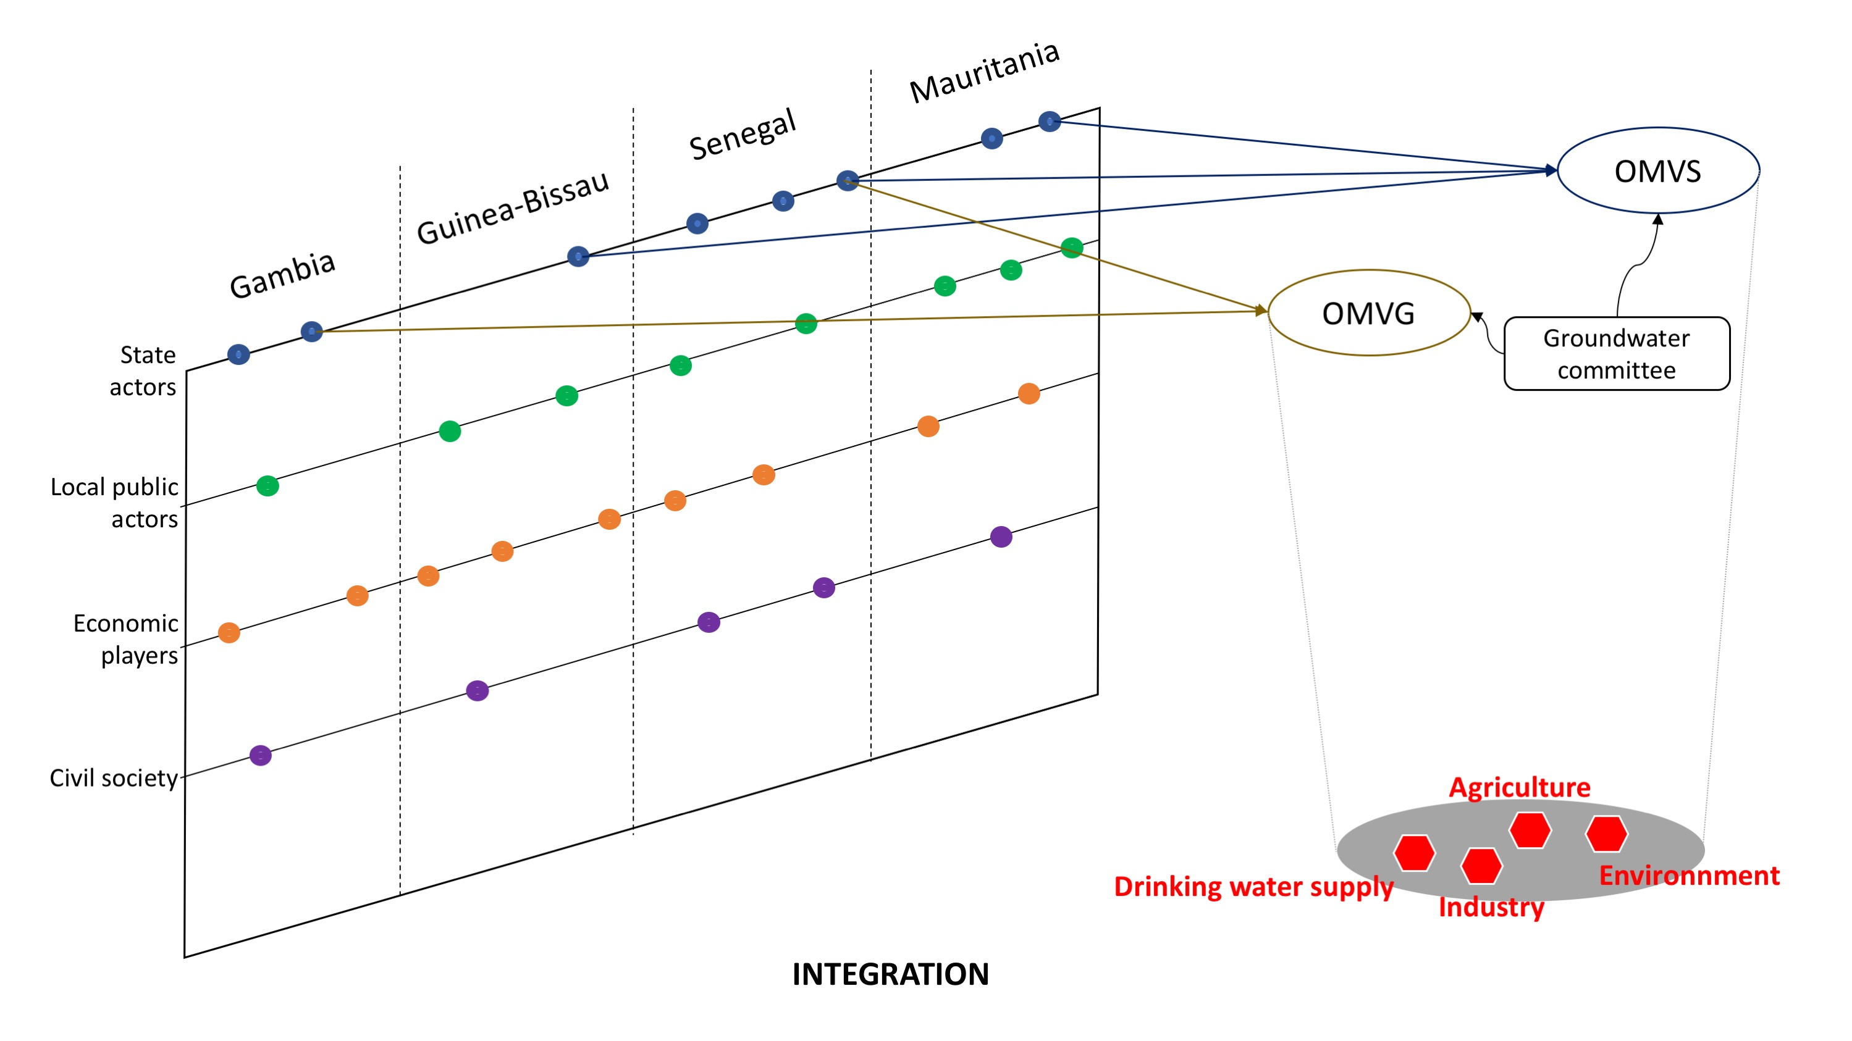

* In the **monofunctional model**, a limited number of stakeholders or industries establish a governance of groundwater uses to address a specific objective (e.g. saltwater intrusion). For example, municipalities and water supply companies implement a joint policy (e.g. a coordination of water withdrawals) to guarantee the provision of the service in the long-run. Depending on issues at stake and national contexts, State actors can be associated to the institutional mechanism. This model has the benefit to focus on a specific issue while gathering umbrella organisations and actors from a sectoral standpoint with the aim to manage user rivalries and prevent possible conflicts (see figure 3).

Fig 3. The monofunctional management regime

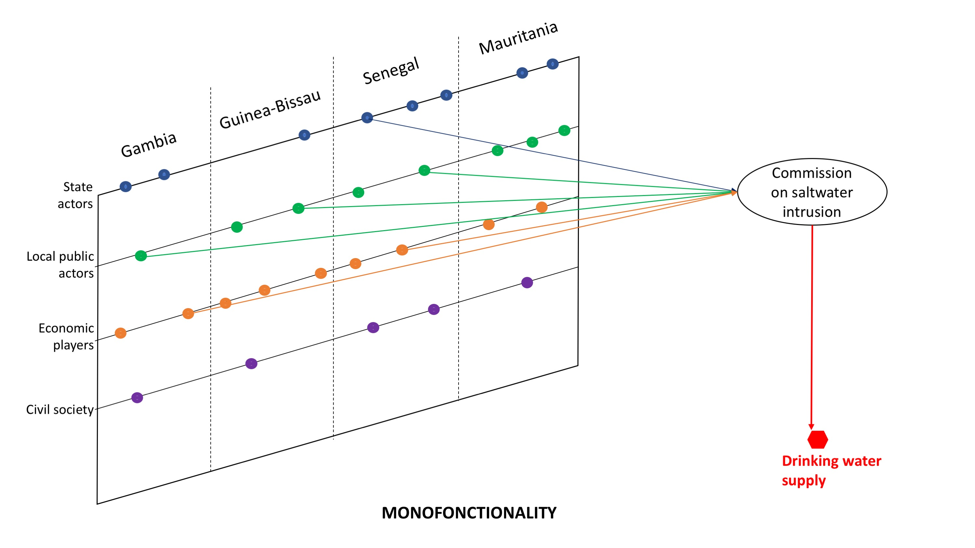

* In the **polycentric model**, the governance is fragmented among different levels and decision centres, including non-governmental organisations, companies, local and national public actors. The design of the management of the resource cannot be anticipated because it depends both of interactions between actors and problems to be tackled. Most often, it takes the form of a contract (legally binding or non-binding) between institutions at different levels. Although the governance structure may appear scattered (see figure 4), this model provides greater institutional flexibility through a proliferation of agreements concluded between a limited number of decision arenas.

Fig 4. The polycentric management regime

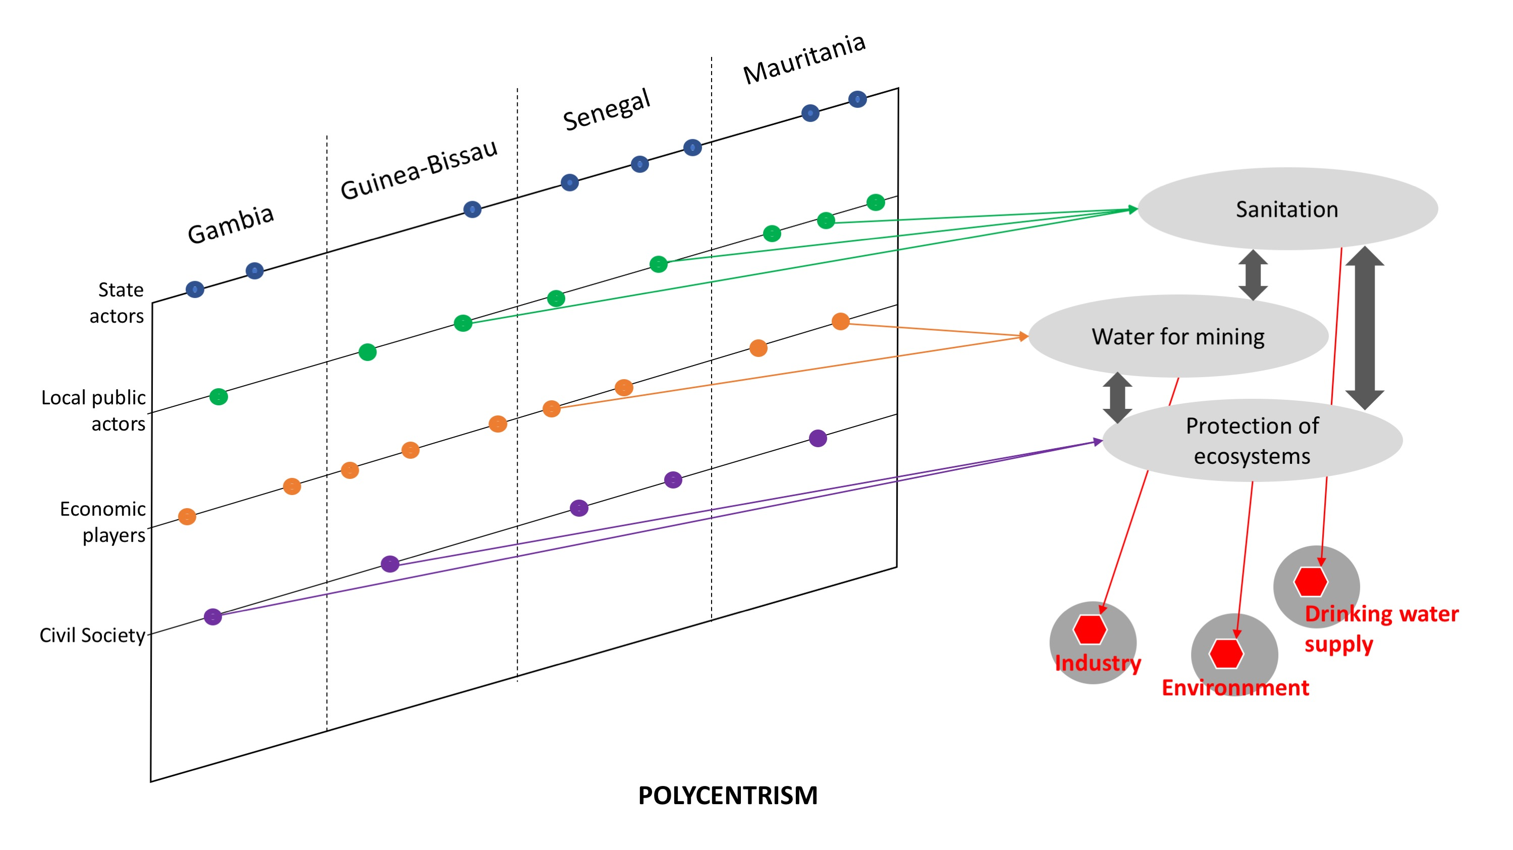

##### References:

Blomquist, W., Dinar, A. and Kemper, K. E. (2005). Comparison of institutional arrangements for river basin management in eight basins. World Bank Policy Research Working Paper 3636

Bréthaut, C., & Pflieger, G. (2020). Governance of a Transboundary River: The Rhône. Springer.

Carter, C., & Smith, A. (2008). Revitalizing public policy approaches to the EU: ‘Territorial institutionalism’, fisheries and wine. Journal of European Public Policy, 15(2), 263–281.

Global Water Partnership. (2000). Integrated water resources management (No. TAC Background Papers No. 4). Retrieved from

https://www.gwp.org/globalassets/global/toolbox/publications/background-papers/04-integrated-water-resources-management-2000-english.pdf.

IGRAC (2015). Transboundary Aquifers of the World. International Groundwater Resources Assessment Centre, UNESCO-IHP.

Jochim, A. E., & May, P. J. (2010). Beyond subsystems: Policy regimes and governance. Policy Studies Journal, 38(2), 303–327.

Lankford, B., & Hepworth, N. (2010). The cathedral and the bazaar: Monocentric and polycentric river basin management. Water Alternatives, 3(1), 82.

Marty, F. (2001). Managing international rivers: Problems, politics and institutions. Food and Agriculture Organization of the United Nations (p. 409). Bern: Peter Lang Publishing.

McGinnis, M. D. (1999). Polycentric governance and development: Readings from the workshop in political theory and policy analysis. Ann Arbor: University of Michigan Press.

Milman, A., Bunclark, L., Conway, D., & Adger, W. N. (2013). Assessment of institutional capacity to adapt to climate change in transboundary river basins. Climatic Change, 121(4), 755–770.

Ostrom, E. (1990). Governing the commons: The evolution of institutions for collective action. Cambridge: Cambridge University Press. Retrieved from

http://dx.doi.org/10.1017/CBO9780511807763.

Ostrom, E. (2008). Institutions and the environment. Economic Affairs, 28(3), 24–31. https://doi.org/10.1111/j.1468-0270.2008.00840.x.

Ostrom, E. (2010). Beyond markets and states: Polycentric governance of complex economic systems. Transnational Corporations Review, 2(2), 1–12.

Ostrom, V., Tiebout, C. M., & Warren, R. (1961). The organization of government in metropolitan areas: A theoretical inquiry. American Political Science Review, 55(4), 831–842.

Pahl-Wostl, C. (2009). A conceptual framework for analysing adaptive capacity and multi-level learning processes in resource governance regimes. Global Environmental Change, 19(3), 354–365. https://doi.org/10.1016/j. gloenvcha.2009.06.001.

Rangeley, R., Thiam, B. M., Andersen, R. A., & Lyle, C. A. (1994). International river basin organizations in Sub-Saharan Africa. Washington, DC: The World Bank.

SADC-GMI. (2019). Framework for Institutionalising Groundwater Management in the SADC Region. SADC GMI report: Bloemfontein, South Africa

Sadoff, C. W., & Grey, D. (2002). Beyond the river: The benefits of cooperation on international rivers. Water Policy, 4(5), 389–403.

Schlager, E., & Blomquist, W. (2000, May). Local communities, policy prescriptions, and watershed management in Arizona, California, and Colorado. Eighth Conference of the International Association for the Study of Common Property, Bloomington, IN, USA.

Varone, F., Nahrath, S., Aubin, D., & Gerber, J.-D. (2013). Functional regulatory spaces. Policy Sciences, 46(4), 311–333.

Young, O. R. (2008). The architecture of global environmental governance: Bringing science to bear on policy. Global Environmental Politics, 8(1), 14–32.

1. Including 226 “groundwater bodies”, according to the community law, which are subject to EU directives.
2. We would particularly like to thank James Sauramba (SADC-GMI Executive Director), Brighton Munyal (SADC-GMI expert), Luiz Amore (Principal Foreign Affairs Advisor, Brazilian National Water Agency), and Gabriel de los Cobos (sector manager basement of the Office for the Environment of the Canton of Geneva) for their constructive comments.